Part D (Marketing)
Analysis of Current Model Results:
Recognized Delivery Delay on Orders
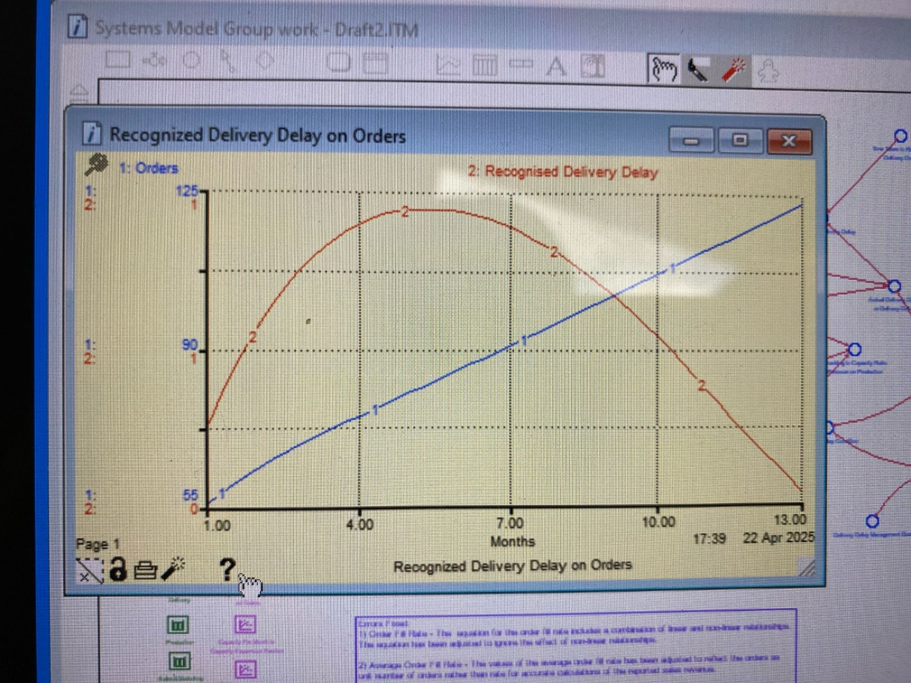
This Graphs showing Orders increasing steadily over time while Recognized Delivery Delay rises then falls.
Capacity Expansion Fraction and Delivery Delay Pressure
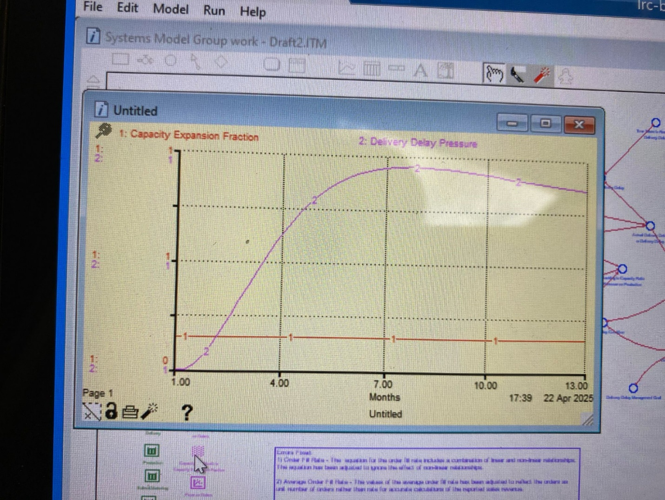
This graph showing relatively flat Capacity Expansion Fraction while Delivery Delay Pressure rises significantly.
Order Backlog to Pressure on Production VS Percentage Utilization
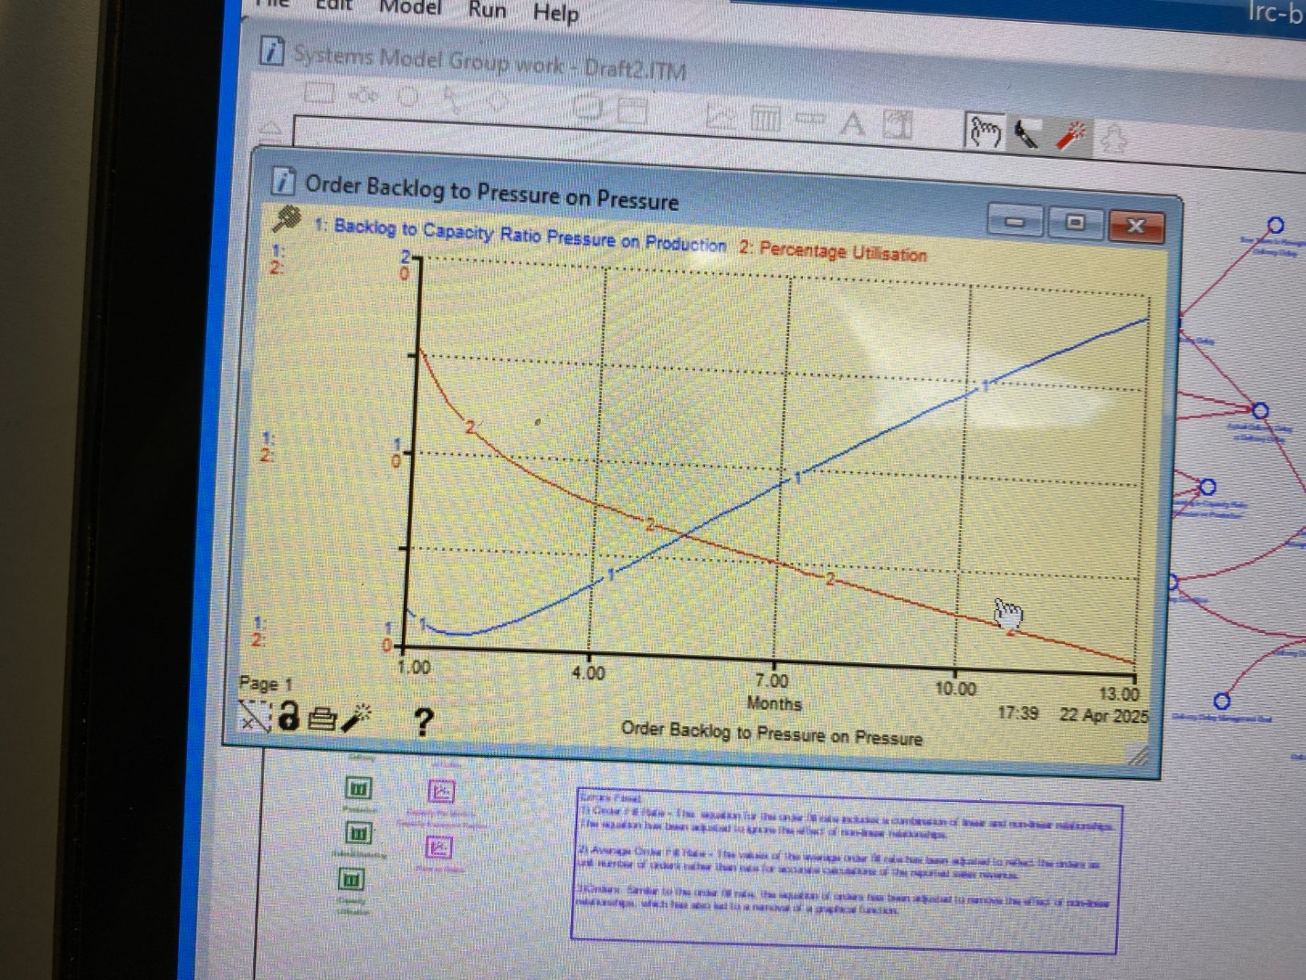
This Graph showing increasing Backlog to Capacity Ratio Pressure on Production while Percentage Utilization decreases.
System Behavior Analysis
The marketing and hiring department is experiencing increasing challenges due to the disconnect between sales generation and production capacity. While the baseline model shows Orders steadily increasing (from approximately 55 to over 120 orders per month in Graph 1), the company's production capacity isn't expanding proportionally as shown by the flat Capacity Expansion Fraction in Graph 2.
The increasing gap between sales and fulfillment is creating a growing Order Backlog (Graph 3), which threatens to undermine the company's reputation for quality and prompt delivery that marketing relies upon. The recognized delivery delay initially peaks but then appears to decline, which suggests a potential misalignment between customer perception and actual delays.
If current policies continue, the company will likely face severe constraints on growth. The primary constraint will be the production capacity's inability to meet the demand generated by marketing efforts and the sales team. This misalignment will eventually cause:
- Increasing customer dissatisfaction due to growing delivery delays
- Potential loss of sales as customers seek alternatives
- Inefficient allocation of resources as marketing generates orders that production cannot fulfill
- Declining reputation in the marketplace, making future marketing efforts less effective

The current Marketing Budget allocation (14% of reported sales revenues) and slow hiring process (6-month average time to hire/fire sales reps) compound these issues by preventing agile adjustments to market conditions.
Proposed Policy Changes
Adaptive Marketing Budget Allocation
- Current policy: Fixed 14% of reported sales revenues allocated to marketing budget regardless of the company's capacity to fulfill orders.
- Proposed change: Implement a dynamic marketing budget allocation that adjusts based on the current delivery delay and production capacity utilization.
- Implementation: Create a formula that reduces marketing spending when delivery delays exceed target thresholds and increases it when capacity utilization is below optimal levels.
- Practical achievement: Marketing department to review budget allocation quarterly based on production capacity metrics from the previous quarter, with authority to adjust allocation between 10-18% depending on system conditions.
Key Parameter Changes:
Marketing budget allocation adjusted from fixed 14% to dynamic range of 10-18%
Time to hire/fire reduced from 6 months to 3 months
Hiring rate doubled when revenue growth exceeds 10% annually

PART E - Recommendations and Advice
Implement Dynamic Marketing Resource Allocation
Replace the fixed 14% marketing budget allocation with a dynamic system that ranges from 10-18% based on current delivery delay conditions
When delivery delays exceed 2 months, automatically reduce marketing budget to avoid generating orders that cannot be fulfilled promptly
When delivery delays are under 1.5 months, increase marketing budget to capitalize on available capacity
This approach will help prevent the reputation damage caused by long delivery times while maximizing growth potential when capacity is available.

